**Brandon – Tudor Knight**

**By Tony Riches**

**New on** [**Amazon UK**](https://www.amazon.co.uk/dp/B07L3YGBWJ) **and** [**Amazon US**](https://www.amazon.com/dp/B07L3YGBWJ)

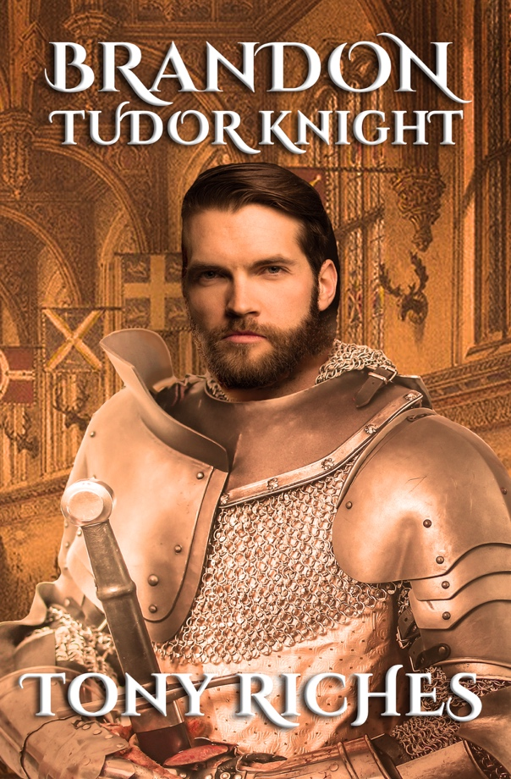*From the author of the international bestselling Tudor Trilogy comes a true story of adventure, courtly love and chivalric loyalty.*

Handsome, charismatic and a champion jouster, Sir Charles Brandon is the epitome of a Tudor Knight. A favourite of King Henry VIII, Brandon has a secret. He has fallen in love with Henry’s sister, Mary Tudor, the beautiful widowed Queen of France, and risks everything to marry her without the King’s consent.

Brandon becomes Duke of Suffolk, but his loyalty is tested fighting Henry’s wars in France. Mary’s public support for Queen Catherine of Aragon brings Brandon into dangerous conflict with the ambitious Boleyn family and the king’s new right-hand man, Thomas Cromwell.

Torn between duty to his family and loyalty to the king, Brandon faces an impossible decision: can he accept Anne Boleyn as his new queen?



**About the Author**

## 

Tony Riches is a full-time UK author of best-selling historical fiction. He lives in Pembrokeshire, West Wales and is a specialist in the history of the Wars of the Roses and the lives of the early Tudors. Tony was a finalist in the 2017 Amazon Storyteller Awards and is listed 130th in the 2018 Top 200 list of the Most Influential Authors. For more information about Tony’s books please visit his website [tonyriches.com](https://www.tonyriches.com/) and his popular blog, [The Writing Desk](http://tonyriches.blogspot.co.uk/) and find him on [Facebook](https://www.facebook.com/tonyriches.author) and Twitter [@tonyriches](https://twitter.com/tonyriches)